Grade 7 Accelerated · Unit 5 · Lessons 8–9  Converting Mass, Area and Volume  Question Bank 5.08 ANSWER KEY | Name  Date  Period

Show your work. Circle your final answer.
For questions 1 through 4, convert with the ratio given.
1. . 20 lb to kilograms.
9.08 kg
(20 ÷ 2.204 = 9.07 by the other ratio.)

2. 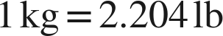. 15 kg to pounds.
33.06 lb

3. . 8 gal to liters.
30.28 L

4. . 25 L to gallons.
6.6 gal

For questions 5 through 7, say how many times the ratio is used.
5. 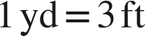. 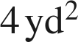 to square feet.
36 ft²
4 × 9: twice.

6.  and . 32 fl oz to liters.
0.96 L
4 c × 0.24.

7. . 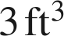 to cubic inches.
5,184 in³
3 × 1,728: three times.

Choose one.
8. . A rug is 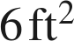 in area. How many square inches is that?
● A. 
○ B. 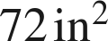
○ C. 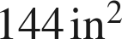
○ D. 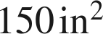
A
6 × 144.

